GR-IX-ARTIFICIAL INTELLIGENCE-QP-I

General Instructions:
- Please read the instructions carefully.
- This Question Paper consists of 21 questions in two sections: Section A & Section B.
- Section A has Objective type questions whereas Section B contains Subjective type questions.
- Out of the given (5 + 16 =) 21 questions, a candidate has to answer (5 + 10 =) 15 questions in the allotted (maximum) time of 2 hours.
- All questions of a particular section must be attempted in the correct order.
- SECTION A - OBJECTIVE TYPE QUESTIONS (24 MARKS):
  - This section has 05 questions.
  - Marks allotted are mentioned against each question/part.
  - There is no negative marking.
  - Do as per the instructions given.
- SECTION B – SUBJECTIVE TYPE QUESTIONS (26 MARKS):
  - This section has 16 questions.
  - A candidate has to do 10 questions.
  - Do as per the instructions given.
  - Marks allotted are mentioned against each question/part.
SECTION A: OBJECTIVE TYPE QUESTIONS
Q. 1 | Answer any 4 out of the given 6 questions on Employability Skills (1 x 4 = 4 marks)
i. | “M D Gulati started with a small shop with his focus, dedication and clear ideas, MDH became one of the most popular brands in India besides having a good reputation all over the world”.  Which self-management skill is clearly visible in the given statement? | 1
ii. | When you bring the mouse over a file in File Explorer, it will show the details of that file.  This is known as  - Drag and drop  - Double click  - Hover  - Single click | 1
iii. | Assertion(A): A doctor works for a renowned hospital.  Reason(R): The statement given above is an example of wage employment.  - Both A and R are correct and R is the correct explanation of A  - Both A and R are correct but R is NOT the correct explanation of A  - A is correct but R is not correct  A is not correct but R is correct | 1
iv. | the work is all about identifying and noting how we spent our time, and analysing how to spend our time effectively.  - Organising  - Prioritising  - Controlling  - Tracking | 1
v. | Remya traveled to Sweden from India to pursue her higher education. But she doesn't know how to speak Swedish (language of Sweden). Because of this, she was unable to find a part time job. This is an example of  - Interpersonal barrier  - Physical barrier  - Organisational barrier  - Linguistic barrier | 1
vi. | “Efforts are made to increase the solar power generation so that our electricity needs are met and at the same time we do not pollute the environment or use up natural resources”.  Which SDG can you relate this statement to?  - Life on land  - Clean water and sanitation  - Affordable and clean energy  - Reduced inequalities | 1

Q. 2 | Answer any 5 out of the given 6 questions (1 x 5 = 5 marks)
i. | Assertion (A)– One can be a good singer while the other can be a great athlete. Reason(R) – Humans possess different types of intelligences but at different levels.  - Both A and R are correct and R is the correct explanation of A  - Both A and R are correct but R is not the correct explanation of A  - A is correct but R is not correct  - A is not correct but R is correct. | 1
ii. | The Indian Government banned a few apps stating – “servers in the hostile nation are receiving and using the acquired data improperly”.  Which terminology suits best for this action?  - AI Ethics  - Data Privacy  - AI Bias  - AI Access | 1
iii. | Statment1: There are four layers in a neural network.  Statement2:The first layer of the neural network is known as the output layer.  - Both Statement1 and Statement2 are correct  - Both Statement1 and Statement2 are incorrect  - Statement1 is correct but Statement2 is incorrect  - Statement2 is correct but Statement1 is incorrect | 1
iv. | Observe the given graph and fill in the blank:  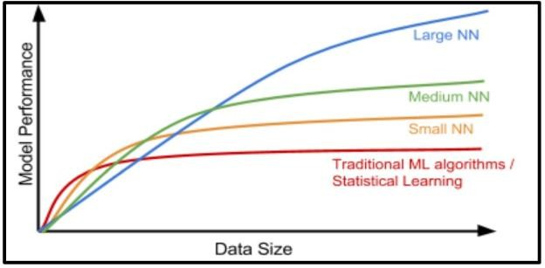  the neural network, better is the performance. | 1
v. | is a simple file format that stores data separated by commas.  - jpg  - doc  - csv  - png | 1
vi. | A corpus contains 4 documents in which the word ‘diet’ was appearing once in document1. Identify the term in which we can categorise the word ‘diet’.  - Stop word  - Rare word  - Frequent word  - Removable word | 1

Q. 3 | Answer any 5 out of the given 6 questions (1 x 5 = 5 marks)
i. | Read the examples given below-  - Using Chat GPT to write an email  - Face unlock technology of mobile phones using camera  - Turning off lights with IoT device  - Hand sanitizer dispenser having sensor Choose the options that are not AI  - i and ii  - iii and i  - iii and iv  - i, iii and iv | 1
ii. | refer to the type of features that we want to collect. | 1
iii. | Which of the following is an application of data science?  - Text summarization  - Target Advertisements  - Face lock in smartphones  - Email filters | 1
iv. | is the process of finding instances of real-world objects in images or videos.  - Instance segmentation  - Object detection  - Classification  - Image segmentation | 1
v. | Identify the given Chat bot type:  It learns from its environment and experience. It also builds on its capabilities based on the knowledge. These can collaborate with humans, working along-side them and learning from their behavior. | 1
vi. | F1 Score is the measure of the balance between  - Accuracy and Precision  - Precision and Recall  - Recall and Accuracy  - Recall and Reality | 1
Q. 4 | Answer any 5 out of the given 6 questions (1 x 5 = 5 marks)
i. | Srishti learnt about AI terminologies but was not able to recollect the term that is used to refer to machines that perform tasks with vast amounts of data using neural networks. Help her with the correct term. | 1
ii. | Statment1: The output given by the AI model is known as reality. Statement2:The real scenario is known as Prediction.  - Both Statement1 and Statement2 are correct  - Both Statement1 and Statement2 are incorrect  - Statement1 is correct but Statement2 is incorrect  - Statement2 is correct but Statement1 is incorrect | 1

iii. | Rajat has made a model which predicts the performance of Indian Cricket players in upcoming matches. He collected the data of players’ performance with respect to stadium, bowlers, opponent team and health. His model works with good accuracy and precision value. Which of the statement given below is incorrect?  - Data gathered with respect to stadium, bowlers, opponent team and health is known as Testing Data.  - Data given to an AI model to check accuracy and precision is Testing Data.  - Training data and testing data are acquired in the Data Acquisition stage.  - Training data is always larger as compared to testing data. | 1
iv. | How many channels does a colour image have? | 1
v. | Which feature of NLP helps in understanding the emotions of the people mentioned with the feedback?  - Virtual Assistants  - Sentiment Analysis  - Text classification  - Automatic Summarization | 1
vi. | Sarthak made a face mask detector system for which he had collected the dataset and used all the dataset to train the model. Then, he used the same data to evaluate the model which resulted in the correct answer all the time but was not able to perform with unknown dataset.  Name the concept. | 1
Q. 5 | Answer any 5 out of the given 6 questions (1 x 5 = 5 marks)
i. | Aditi, a student of class XII developed a chatbot that clarifies the doubts of Economics students. She trained the software with lots of data sets catering to all difficulty levels. If any student would type or ask questions related to Economics, the software would give an instant reply. Identify the domain of AI in the given scenario.  - Computer Vision  - Data Science  - Natural Language Processing  - None of these | 1
ii. | Which evaluation parameter takes into consideration all the correct predictions? | 1
iii. | means a picture element which is the smallest unit of information that makes up a picture.  - Vision  - Pics  - Pixel  - Piskel | 1
iv. | What do you mean by syntax of a language?  - Meaning of a sentence  - Grammatical structure of a sentence  - Semantics of a sentence  - Synonym of a sentence | 1

v. | Which algorithms result in two things, a vocabulary of words and frequency of the words in the corpus?  - Sentence segmentation  - Tokenisation  - Bag of words  - Text normalisation | 1
vi. | Which one of the following scenario result in a high false positive cost?  - viral outbreak  - forest fire  - flood  - spam filter | 1
SECTION B: SUBJECTIVE TYPE QUESTIONS
Answer any 3 out of the given 5 questions on Employability Skills (2 x 3 = 6 marks) Answer each question in 20 – 30 words.
Q. 6 | List two best practices for effective communication. | 2
Q. 7 | What is the importance of setting goals in life? | 2
Q. 8 | “The Trojan Horse was a wooden horse said to have been used by the Greeks during the Trojan War to enter the city of Troy and win the war”.  What does Trojan horse mean in computer terminology? | 2
Q. 9 | How is society helping entrepreneurs in their business? | 2
Q. 10 | Mention any two human activities that lead to environmental degradation. | 2
Answer an 4 out of the given 6 questions in 20 – 30 words each (2 x 4 = 8 marks)
Q. 11 | All of us use smartphones. When we install a new app, it asks us for several permissions to access our phone’s data in different ways. Why do apps collect such data? | 2
Q. 12 | Sirisha and Divisha want to make a model which will organize the unlabeled input data into groups based on features. Which learning model should they use and why? | 2
Q. 13 | Ajay wants to access data from various sources. Suggest him any two points that he needs to keep in mind while accessing data from any data source. | 2
Q. 14 | Explain the term resolution with an example. | 2
Q. 15 | Identify any two stop words which should not be removed from the given sentence and why?  Get help and support whether you're shopping now or need help with a past purchase. Contact us at abc@pwershel.com or on our website www.pwershel.com | 2
Q. 16 | Draw the confusion matrix for the following data  - the number of true positive = 100 | 2

- the number of true negative 47
- the number of false positive = 62
- the number of false negative = 290
Answer any 3 out of the given 5 questions in 50– 80 words each (4 x 3 = 12 marks)
Q. 17 | Your grandmother watches you use AI applications. She wants to understand more about it. Help her understand the term artificial intelligence by giving the right definition and explain to her with an example how machines become artificially intelligent. | 4
Q. 18 | Akhil wants to learn how to scope the problem for an AI Project. Explain him the following:  - 4W Problem Canvas  - Problem Statement Template | 4
Q. 19 | Identify and explain the types of the learning-based approaches in the figures given below.  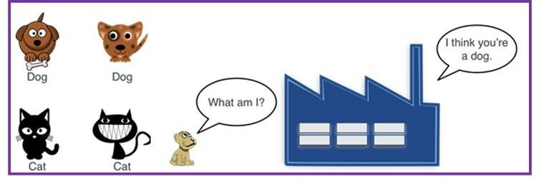  Figure 1  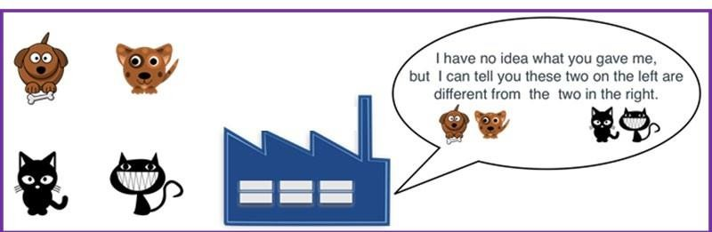  Figure 2 | 4
Q. 20 | We, human beings, can read, write and understand many languages. But computers can understand only machine language. Do you think we might face any challenges if we try to teach computers how to understand and interact in human languages? Explain. | 4
Q. 21 | An AI model made the following sales prediction for a new mobile phone which they have recently launched:  - Identify the total number of wrong predictions made by the model.  - Calculate precision, recall and F1 Score. | 4
  Confusion Matrix |  | Reality
   |  | Yes | No
  Prediction | Yes | 50 | 40
  Prediction | No | 12 | 10

